**30 EPOCHES TRAINED WITH 25 SEQUENCE LENGTH AND SPLIT 10**

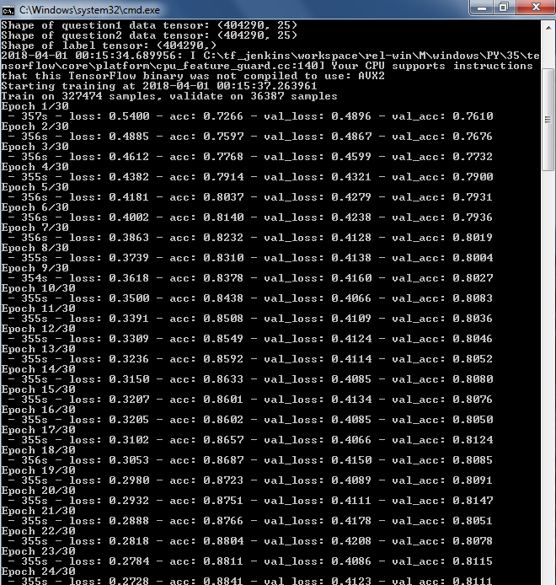

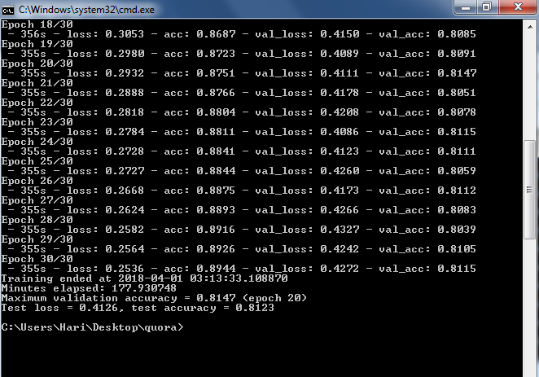

With 404290 30 epoches

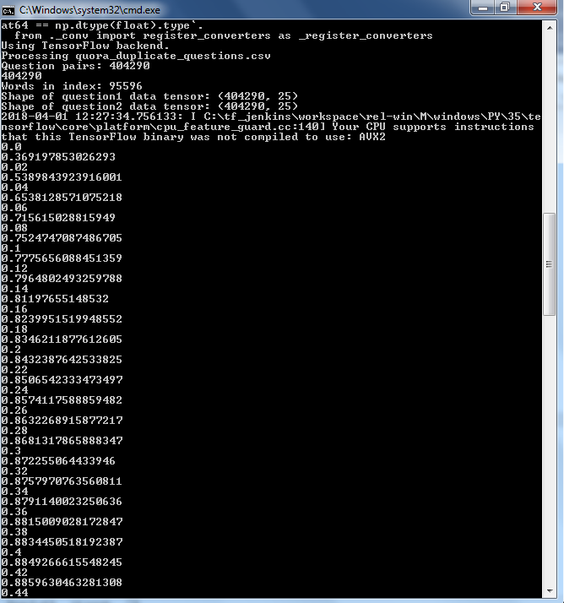

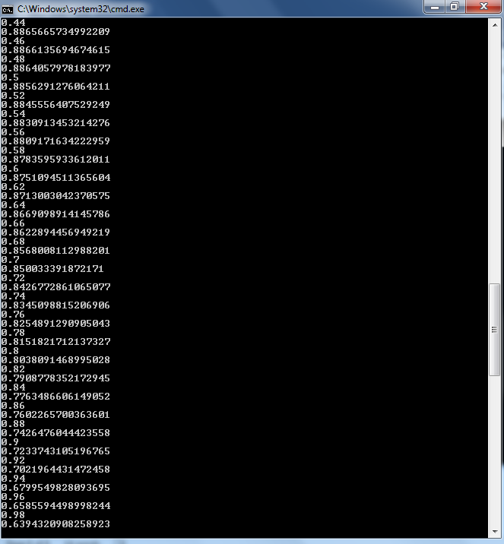

>0.5 =1

<=0.5 = 0